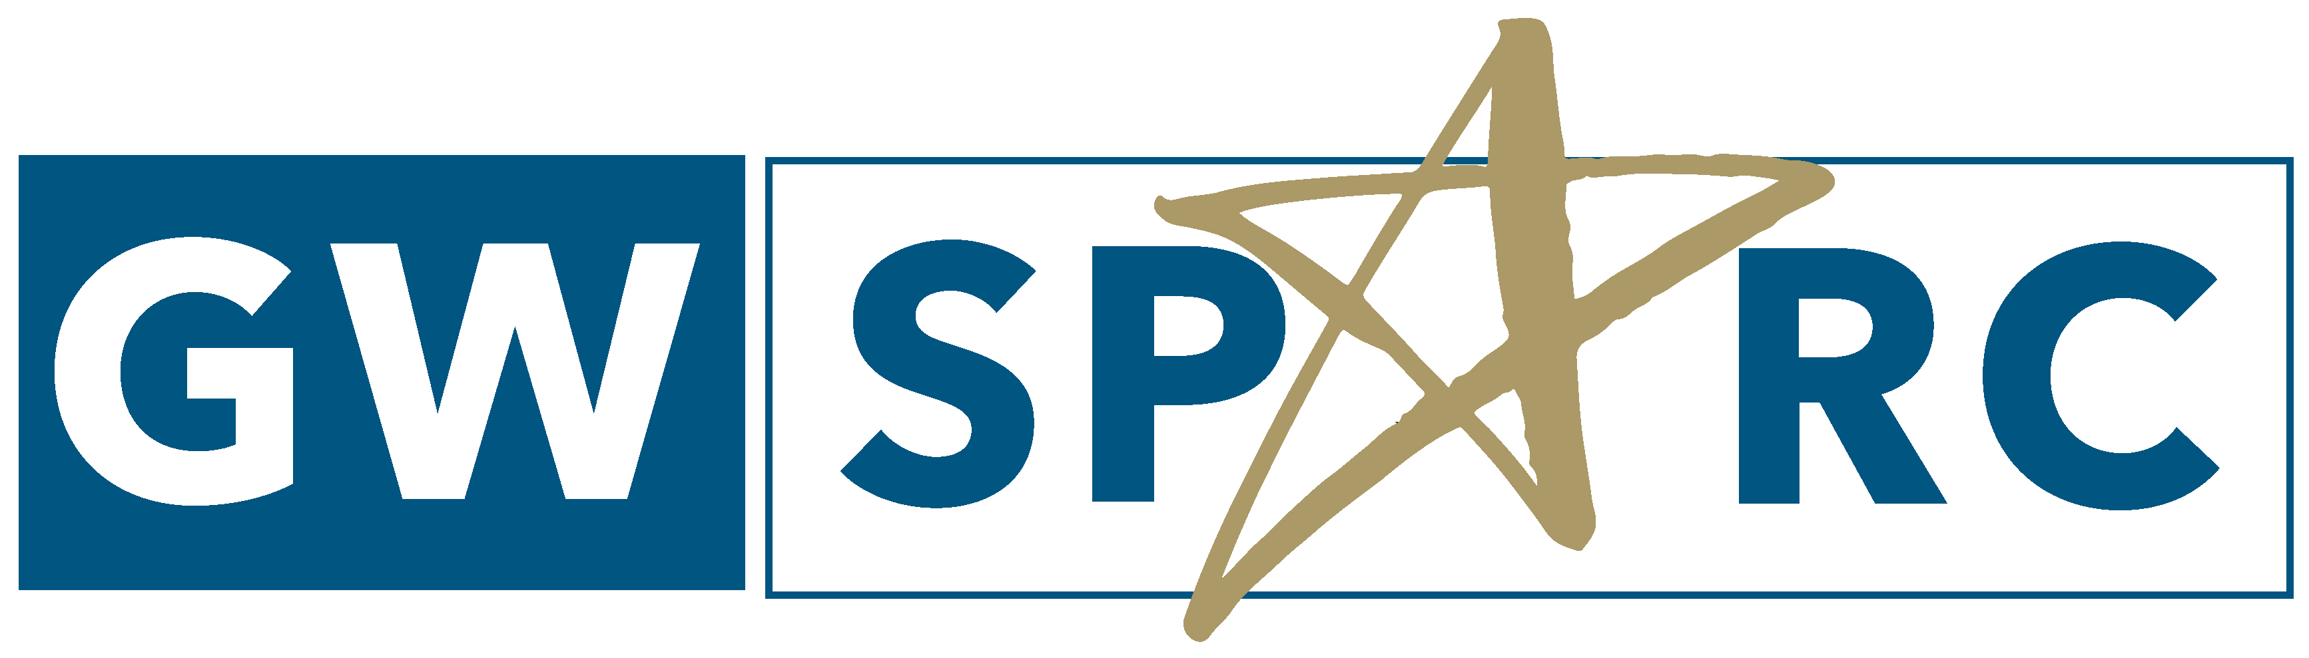2023 Program Schedule
Date | Time | Room | Event
Sunday, May 28 |  | Madison Hall | Arrival at GW, Dorm check-In
Monday, May 29 | 12 PM | Madison Hall | Memorial Day Holiday
Tuesday, May 30 | 9:15 AM  9:30 AM-12PM | Ross Hall Lobby  Ross Hall 602 | Meet at Ross Hall lobby (Pesha)  Biosafety Training labsafety@gwu.edu (9:30 AM – 11 AM)/ Lab Safety Training safety@gwu.edu (11AM-12 PM)  Pick up GWorld Card, 800 21st St NW, Suite 204  Afternoon your own
Wednesday, May 31 | 9:30-10 AM  10-11:30 AM  12-1 PM (L)  1-5 PM | Ross Hall 602  Ross Hall 602/643 | Program Orientation (Drs. Hall, Seto)  Lab Culture, Notebooks, Scientific Integrity, Serial Dilution Activity, SPARC intern survey  Lunch with students and supervisors, leave to your lab
Thursday, June 1 | 1:30 – 2:30 PM | Ross Hall Plaza | Ice Cream Social – with summer chemistry undergrads
Tuesday, June 6 | 12-1 PM (L) | Ross Hall 643 | Seminar: Dr. Norman Lee, "Functional Impact of Alternative Splicing in Cancer Health Disparities"
Thursday, June 8 | 3-4 PM | Ross Hall 643 | Workshop: Sample Size and Experimental Design
Tuesday, June 13 | 12-1 PM (L) | Ross Hall 402 | Seminar: Dr. Elmer Huerta, "Cancer Health Disparities"
Thursday, June 15 | 3-4 PM | SEH 8th floor | Workshop –Flow Cytometry in Cancer (Dr. Greg Cresswell)  Group 1
 | 4-5 PM |  | Group 2
Monday, June 19 |  |  | Juneteenth Holiday
Tuesday, June 20 | 12-1 PM (L) | Ross Hall 643 | Seminar: Dr. Kate Chiappinelli, "The role of 'junk DNA' in the immune response to cancer" (MS1 METEORs join)
Thursday, June 22 | 3-4 PM | Ross Hall 643 | Workshop: Applying to Graduate and Medical School (Dr. Alison Hall)
Tuesday, June 27 | 12-1 PM (L) | Ross Hall 643 | Seminar: Dr. Jocelyn Rapelyea, "Breast Cancer Imaging and intervention”
Wednesday, June 28 | 1:30 – 4 PM | Ross Hall 402 | Movie Screening & Discussion: The Immortal Life of Henrietta Lacks, (discussion moderator Dr. Chavon Onumah)
Tuesday, July 4 |  |  | 4th of July Holiday
Wednesday, July 5 | 12-1 PM (L) | Ross Hall 643 | Seminar: Dr. Maho Shibata, “Modeling prostate cancer using mice and organoids”
Thursday, July 6 | 3-4 PM | Ross Hall 602 | Workshop: After the Internship: National Research Meetings & Diversity Supplements (Dr. Alison Hall)
Tuesday, July 11 | 12-1 PM (L) | Ross Hall 643 | Seminar: Dr. Carla Berg, “Tobacco and Marijuana Policy and Industry Evolution"
Thursday, July 13 | 3-4 PM | Ross Hall 602 | Book Club: Under the Skin: The Hidden Toll of Racism on Health in America, by Linda Villarosa
Wednesday, July 19 | 9 AM-5 PM | Metro to NIH | NIH Graduate and Professional School Fair
Thursday, July 20 | 3-4 PM | Ross Hall 602 | Workshop: Making a Poster (Paul Levett)
Monday, July 24 |  |  | Abstracts due to pesha.rubinstein@mail.gwu.edu for Poster Session Booklet
Tuesday, July 25 | 12-1 PM (L) | Ross Hall 643 | TBD
Thursday, July 27 | 3-4:30 PM | Ross Hall 602 | TBD
Monday, July 31 |  |  | Poster due to pesha.rubinstein@mail.gwu.edu for printing
Tuesday, August 1 | 12-1 PM | Ross Hall 643 | Seminar: Dr. Rohan Fernandes
Thursday, August 3 | 9am-12 PM | SEH lower level lobby –green wall | Poster Session
Friday, August 4 | 12 PM | Ross Hall 707 (Weingold) | Farewell lunch and survey  Last day of program
Saturday, August 5 |  |  | Check out of dorms

